**MKT261 - Assignment 1**

**Marketing Environment - McDonald’s**

Student Name: **ABU BAKER GUL**

Student ID: **20194401**

MKT 261: **Section: 9**

**This assignment is DUE ON THURSDAY, MARCH 25, 2021 and the assignment is worth 15%. FOLLOW THE DIRECTIONS FULLY, NO LATE ASSIGNMENTS, & SUBMIT THE ASSIGNMENT ON BLACKBOARD (Under “Content”, then “Assignment” folder, then click on the link to upload and submit the assignment using a WORD DOCUMENT.**

**Answer the following questions below completely. Save and name the WORD DOCUMENT (ONLY) file using your first name and student ID (e.g.: “Youssef – 20181234”).**

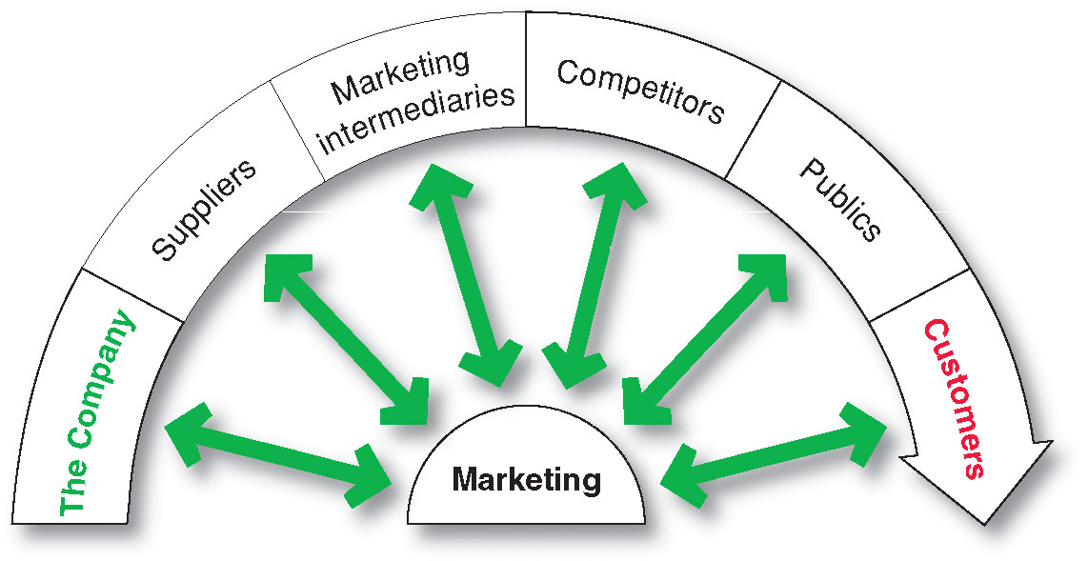

**McDonald’s** – based on the international company, McDonald’s. **ANSWER & FULLY EXPLAIN** the following information for each part of the **Microenvironment** below. ***(2 points each)***

1. **The Company** – provide and explain at least 2 types of products that the company sells.

**1: Burgers:** One of the selling products from MC Donald’s is burgers. MC Donald’s sells one of the world best burger according to the sales named as Big Mac. MC Donald’s includes different kinds of burger with different size and cost. Different kinds of burgers like MC Royale are sold. For breakfast burgers like Egg MC Muffin are sold.

**2: Deserts and Shakes:** The Company sells many products. In deserts and shakes category one of product that the company sells is ice cream cone. It is one of the cheapest products in MC Donald’s, with a price of just 100 files in Bahrain. It is Vanilla flavor and consists of a Sundae mix and a cone.

1. **Suppliers** – Provide at least 2 suppliers for McDonald’s and what materials do they supply? ***(state the actual names of suppliers and materials)***

**1: Coca cola:**

Coca cola is one of the main suppliers of McDonald’s. They are partners from 1955. It provides different kind of beverages like coca cola, sprit Fanta, and diet coke. It served with different meals. 600 files is a price of normal size for coca cola products in Bahrain.

**2: Fries:**

Simplot is one of the companies that supplies fries to McDonald’s. They are supplying them from around 1970. Other companies also supply fries to them but Simplot is top of them. It is made with vegetarian oil with a beef flavor. And serve to the customer with French fries box.

1. **Marketing Intermediaries** – Provide at least 2 different types of marketing intermediaries that deal with McDonald’s and what do they help McDonald’s with? ***(state the actual names of intermediaries and what do they help with)***

**Answer:** Talabat is one of the types of physical distribution firm that help MC Donald’s to sell his product. It receives the order from the MC Donald’s and delivers it to the customer. Financial intermediaries like Benefit pay, Credimax that allow customer to pay with their credit card or online. These marketing intermediaries help McDonald’s in selling their product.

1. **Competitors** – Identify at least 2 different competitors and what is their position compared to McDonald’s? Who is the leader globally or locally (based on their sales or brand value)?

**Answer:** In Bahrain the strong competitor of MC Donald’s are Jasmis and KFC. Both this two companies have high sales and customers. These companies have more braches than MC Donald’s in Bahrain. KFC has 19 branches in Bahrain, whereas Jasmis have 31 branches in Bahrain, which makes Jasmis the leader in selling and their brand value in Bahrain.

1. **Publics** – Provide at least 2 different types of Publics that are affected or have an interest in McDonald’s.

**1: General publics:**

General public may have interest in MC Donald’s. As MC Donald’s is all over the world, every person can visit, buy or eat food in MC Donald’s. Through General public’s MC Donald’s can sell their most of their product and earn revenue.

**2: Media publics:**

Media publics may affect MC Donald’s. Different channels may broadcast MC Donald’s advertisement that may attract new customers. Social media platform such as Instagram, face book, twitter that may help people to visit their page to find discounts and new updates.

1. **Customers** – Identify the different types of consumers/customers groups that are served by McDonald’s.

**Answer:** Through different marketing strategies McDonald’s targets different types of customer’s especially younger generation. It serves internationally to all groups of people. McDonald’s serve both local and global markets based on different geographic locations. They target different groups of segments such as based on regions, age, populations and other statistics.

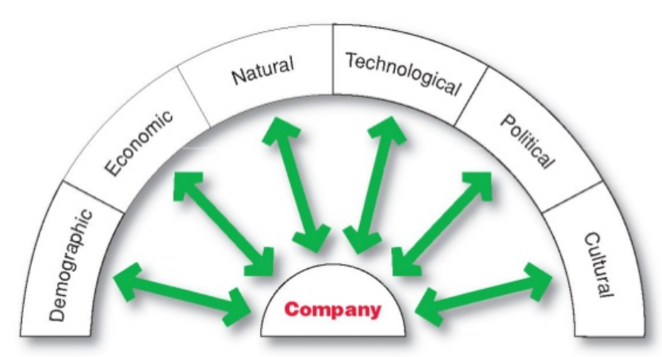

**MACRO ENVIRONMENT** – based on McDonald’s **IN BAHRAIN**, BRIEFLY EXPLAIN ALL of the forces that have affected McDonald’s in Bahrain during the CORONA/COVID-19 VIRUS and how did McDonald’s respond and adapt? ***(YOU NEED TO EXPLAIN AT LEAST 3 FORCES)*** ***(3 points)***

**1: Political environment:**

Due to corona virus Government had made all public places like restaurant to be closed because of gathering and spreading of corona virus. Even a single customer is not allowed to set in McDonald’s or any other restaurant to set and eat. That has highly affected their sales due to decrease of their customers from coming.

**2: Demographic environment:**

Demographics environment means people involve in marketing. Many companies are in loss due to corona virus, which causes to downsize their employees. People are lockdown in their houses and stop investing. Because of that high number of customers are reduced, which have highly affect Bahrain economy and MC Donald’s sales.

**3: Technological environment:**

People are now placing their order online like ordering on MC Donald’s application, that help MC Donald’s to receive the order and sell their products with the help of technology.

**Answer: McDonald’s providing a safety environment for both their employees and customers in the current circumstances precautions like, using sanitizers, and social distancing and much more in response to corona from spreading.**